HDMI 1.4 receiver

Overview
HDMI 1.4 receiver enables digital video, audio, and control data reception that is transmitted via HDMI. It has a High-Bandwidth Digital Content Protection (HDCP) 1.4 decryption and control unit that enables the reception of content protected material. Apart from standards like CEC, it also supports interfaces like APB, Video Output, Audio Output, Interrupt output, and HDMI PHY interface.

General Description
The HDMI stream is composed of audio, video, and configuration and status data. These components are transmitted in a particular order. HDMI 1.4 receiver used to post-process incoming data with respect to the following:
■ Protocol-dependent stream
■ Stream de-multiplexing
■ Content protection, scheme-related decryption
■ Packet assembly and formatting
■ Audio output stream formatting

Architecture
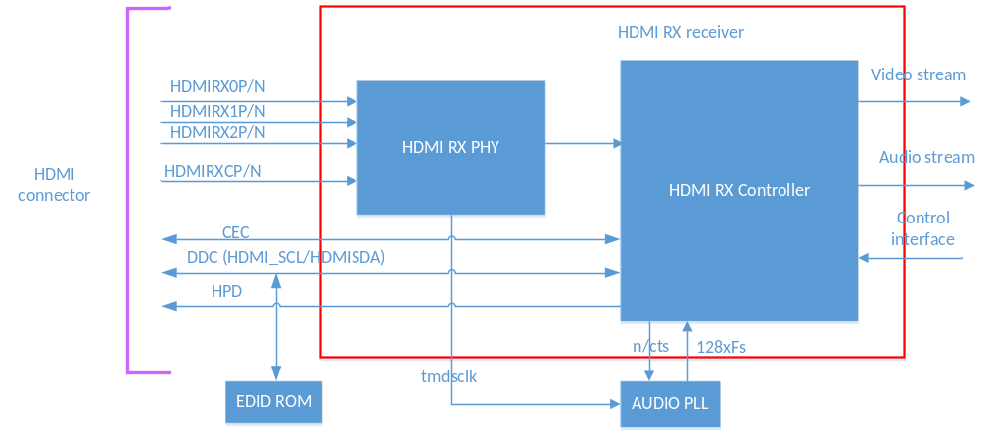
HDMI RX Structure

Functional description
Video input formats:
❑ RGB 4:4:4
■ 8-bit normal color mode
■ 10-, 12-, and 16-bit deep color mode
❑ YCBCR 4:2:2 with 8-, 10-, and 12-bit color depth
❑ YCBCR 4:4:4
■ 8-bit normal color mode
■ 10-, 12-, and 16-bit deep color mode
Receipt of compressed and uncompressed encoded audio data:
❑ L-PCM
❑ L-PCM multi-channel
❑ Standard bit-rate compressed audio
❑ 1-bit audio (DSD)
❑ Compressed 1-bit audio (DST) and High Bit-Rate (HBR) compressed audio
CEC Controller
CEC is a protocol that provides high-level control functions between all of the various audiovisual products in your environment. The CEC bus allows all products in the system to potentially discover and communicate with each other

